Contributor: David Fernando Cortés Saavedra

**Xul Solar**

Born Oscar Agustín Alejandro Schulz Solari: 1887 -San Fernando, Buenos Aires Province ; Died: 1963- Trigre, Buenos Aires Province.

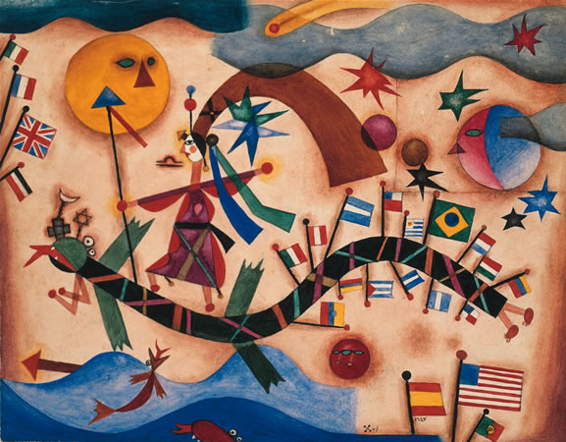

Xul Solar, Drago, 1927 http://www.xulsolar.org.ar/coleccion1920.php

Associated with the most important figures of the literary and artistic avant-garde of Buenos Aires, the Argentinean painter and polyglot Xul Solar was key in connecting European movements like Expressionism, Constructivism and Dadaism to Latin American modernism. He contributed to the modernist project via the convergence in his work of depurated (simplified) flat colorful figuration and a complex iconography of pre-Columbian and religious derivation. Xul Solar lived during his youth in San Fernando, Argentina, and was equally inclined towards music and the visual arts. During a long period of travel throughout Europe, he encountered several artistic movements – from the Italian Renaissance to *die Brücke* – and studied linguistics and theosophy. Enthralled by his experiences abroad, Xul Solar returned to Argentina in 1924, joining the artist group Martín Fierro and elaborating on projects begun in Europe such as the creation of his artificial language, Panlingua. His fascination with elaborate semiotic systems also led him to create the game PanChess. Xul Solar’s visual works varied throughout his career from geometric abstraction to schematic figuration, from fantastic paintings to symbolic portraits. Xul Solar remains one of the most influential Latin American artists of the modern period.

Xul Solar devoted himself in his early career to both music and the visual arts, as well as architecture, playing the violin and the piano while studying to become an architect (he did not complete his studies.) Before leaving for London in 1912, Xul Solar worked in the remodelling of the printing press of the national Argentinian prison, a building which would become a motif of the plastic work he produced during the 1940s. After a short stay in London, the artist travelled to Turin, where he was influenced by the expressionist painters of *Die Brücke* [The Bridge]. Later the artist was enthralled by the work of the Renaissance painters in Florence and by the art of ancient Hinduism that he experienced in Rome.

Around 1918, Xul Solar turned to a flat and schematic figuration taking from geometric abstraction. This shift is clearly visible in works as *Troncos* (1919) and *Pupo* (1918). Also during this time he encountered the main figures of the theosophical society. Under their influence, Xul Solar began to modify the spelling of the Spanish language, leading him to the creation of an artificial language called Neocriollo. During the 1920s, Xul Solar developed a translucent and fantastic style of painting using subtle glazes and symbolic pre-Columbian imagery, visible in watercolor such as *Nana Watzin* (1923) or *Taloc* (1923).

Xul Solar returned to Argentina in 1924 with the Argentinian painter Emilio Pettoruti, and became a member of the Martín Fierro circle. Between 1930 and 1960 his work can be divided into series gathered around principal motifs: masks and symbolic portraits; architectures (in which pyramidal buildings and staircases dominate the landscape); the series *Grafías,* where we find abundant use of stenographic symbols and hook-like shapes; and the series of *Grafías plastiútiles,* in which various systems of symbolic writing are developed. Xul Solar was highly engaged with these writing systems during the 1930s and 1940s. He continued to develop PanLingua, an artificial language with no grammatical exceptions, ruled by a precise coincidence between phonetic and semantic values. During the same period, the artist simultaneously also worked on PanChess, a modified chess game based on the mathematical duodecimal system, and developed a modified piano with a double set of keys which allowed the use of semitones. Xul Solar was fictionalized by Leopoldo Marechal in the novel *Adán Buenosayres* (1948) and was also a close friend of Jorge Luis Borges. In a 1965 public conference, Borges said “I met Xul Solar, and I knew that I had never dealt with any man of such a rich, heterogeneous, unpredictable and everlasting imagination” (Xul Solar 2012). Xul Solar’s work has remained highly influential in Latin America and particularly in his home country Argentina.

**References and further reading:**

Abós, Álvaro. 2004. *Xul Solar: Pintor Del Misterio*. 1. ed. Biografías Y Testimonios. Buenos Aires: Ed. Sudamericana.

Gradowczyk, Mario Horacio, Jorge Luis Borges, and Roberto Aizenberg. 1988. *Alejandro Xul Solar: 1887 - 1963 ; En Conmemoración Del Centenario Del Nacimiento de Xul Solar Y En Ocasión de La Exposición ... Entre El 8 Y El 20 de Agosto de 1988 En La Galería Kramer, Buenos Aires*. Buenos Aires: Galería Kramer.

Xul Solar. 2012. *Los San Signos. Xul Solar Y El I Ching.* Patricia M. Artundo. Catena Aurea. Buenos Aires: El Hilo De Ariadna.

Xul Solar, Alejandro. 2005. *Entrevista, Artículos Y Textos Inéditos*. Edited by Patricia M. Artundo. 1. ed. Buenos Aires: Corregidor.

Museo Xul Solar. Fundación Panklub. <http://www.xulsolar.org.ar/>

**List of works**

Troncos (1919. Watercolor)

Tu y yo (1923. Watercolor)

Nana Watzin (1923. Watercolor)

País duro en noche clara (1933.Watercolor)

Panchess (c.a.1930. Wood)

Grafía Ántica (1939. Watercolor)

Zodíaco (1953. Watercolor mounted on wood structure)

El Sei rey wan. Telud. / Konra to kredu diu / Lujan se / Bei Santa. Worker” (1959. Watercolor mounted on cardboard)